https://www.geeksforgeeks.org/taking-input-in-python/?ref=lbp

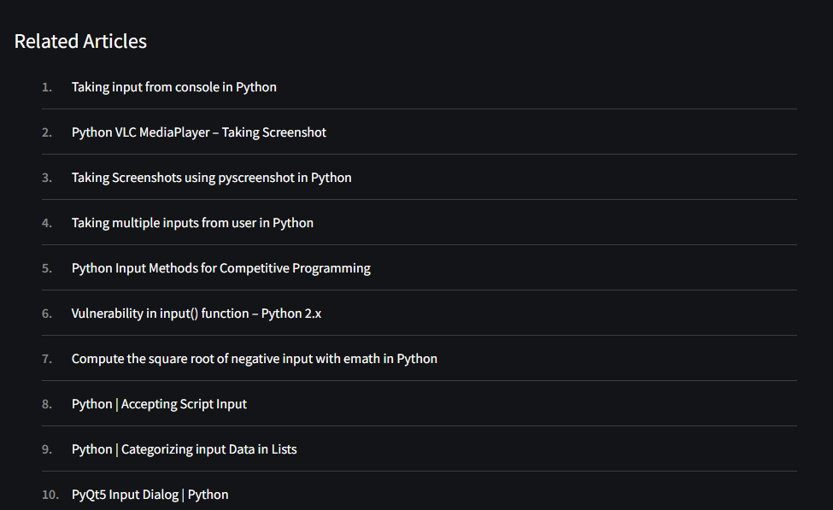

[https://www.geeksforgeeks.org/python-output-using-print-function/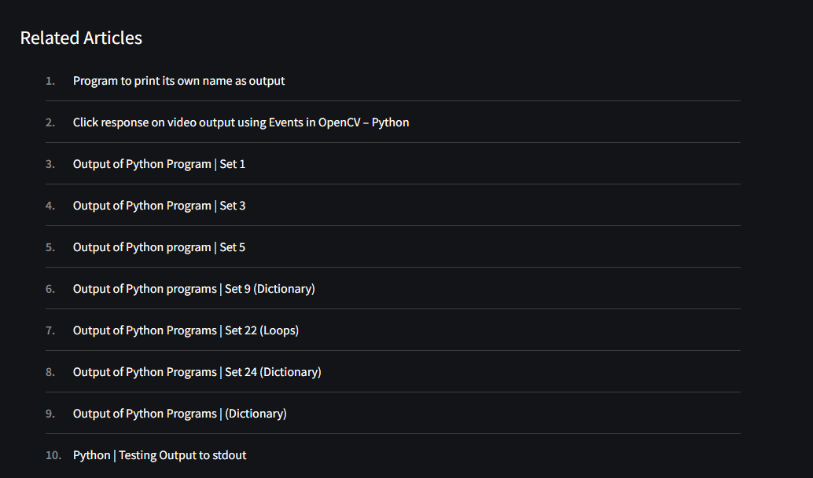](https://www.geeksforgeeks.org/python-output-using-print-function/#)

<https://www.geeksforgeeks.org/python-print-initials-name-last-name-full/?ref=rp>

<https://www.onworks.net/os-distributions/ubuntu-based/free-ubuntu-online-version-20>

<https://killercoda.com/playgrounds/scenario/ubuntu>

https://killercoda.com/playgrounds/scenario/ubuntu